DECISION TREE REGRESSION Assignment
R-Score with different parameter combinations, for every R-Score, we are creating a new model

S.No | Criterion | Max Features | Splitter | RValue
1 | Absolute_error | auto | best | 0.9493726735323613
2 | Absolute_error | auto | random | 0.5780023619811279
3 | Absolute_error | sqrt | best | 0.5642127299861528
4 | Absolute_error | sqrt | random | -0.5014681210604035
5 | Absolute_error | Log2 | best | 0.5752657964430266
6 | Absolute_error | Log2 | random | 0.2174827794013896
7 | poisson | auto | best | 0.9318880262356684
8 | poisson | auto | random | 0.8876629502127538
9 | poisson | sqrt | best | 0.42313512471580794
10 | poisson | sqrt | random | 0.7524659638413829
11 | poisson | Log2 | best | 0.8882213599783344
12 | poisson | Log2 | random | 0.9454810225284668
13 | Friedman_mse | auto | best | 0.9141972921025665
14 | Friedman_mse | auto | random | 0.9324051807868639
15 | Friedman_mse | sqrt | best | 0.5639936898293063
16 | Friedman_mse | sqrt | random | 0.610034721887075
17 | Friedman_mse | Log2 | best | 0.6586406993603734
18 | Friedman_mse | Log2 | random | 0.25501938600153373

Absolute_error | auto | best

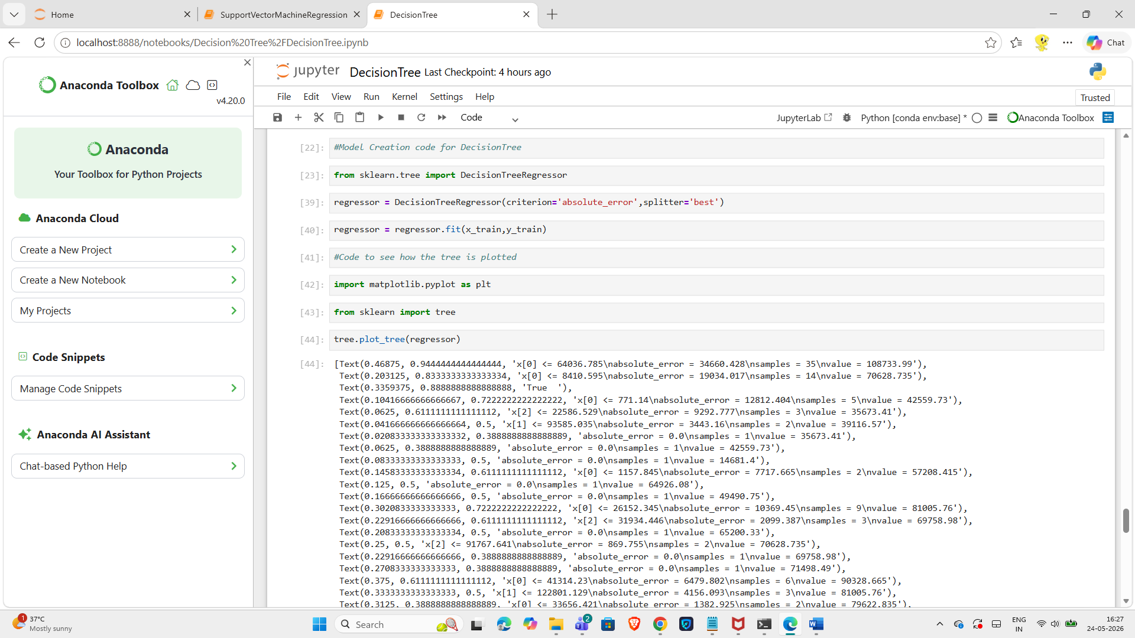
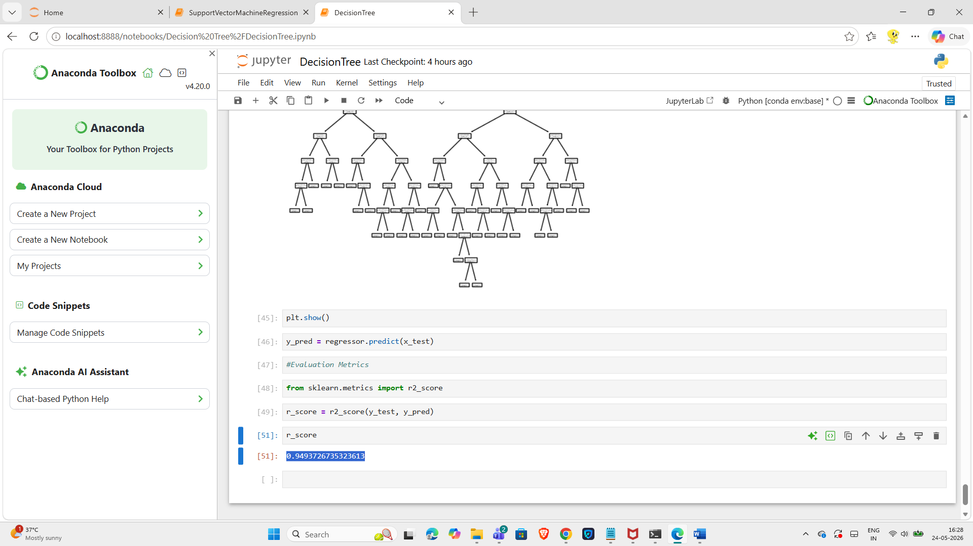

Absolute_error | auto | random

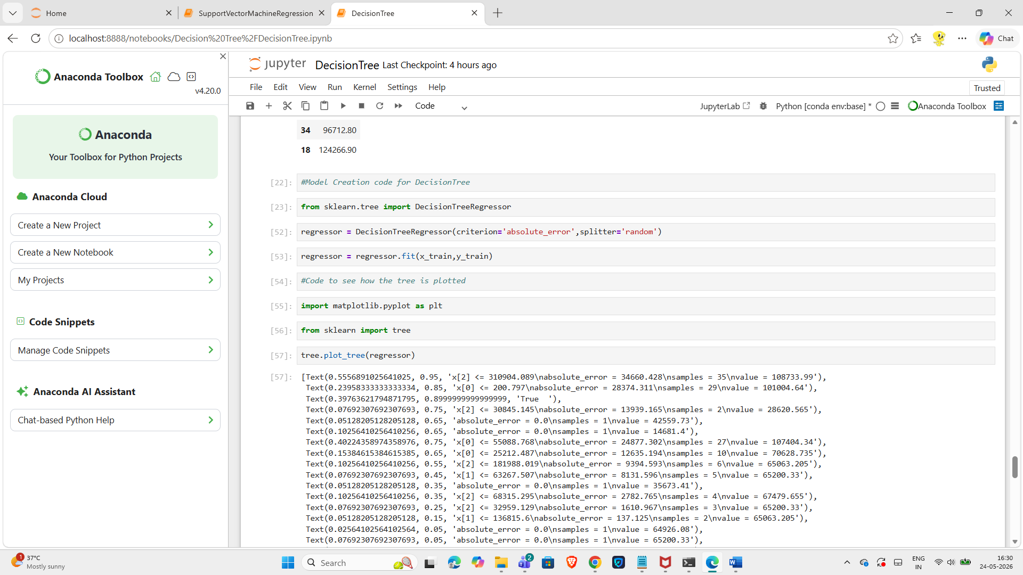
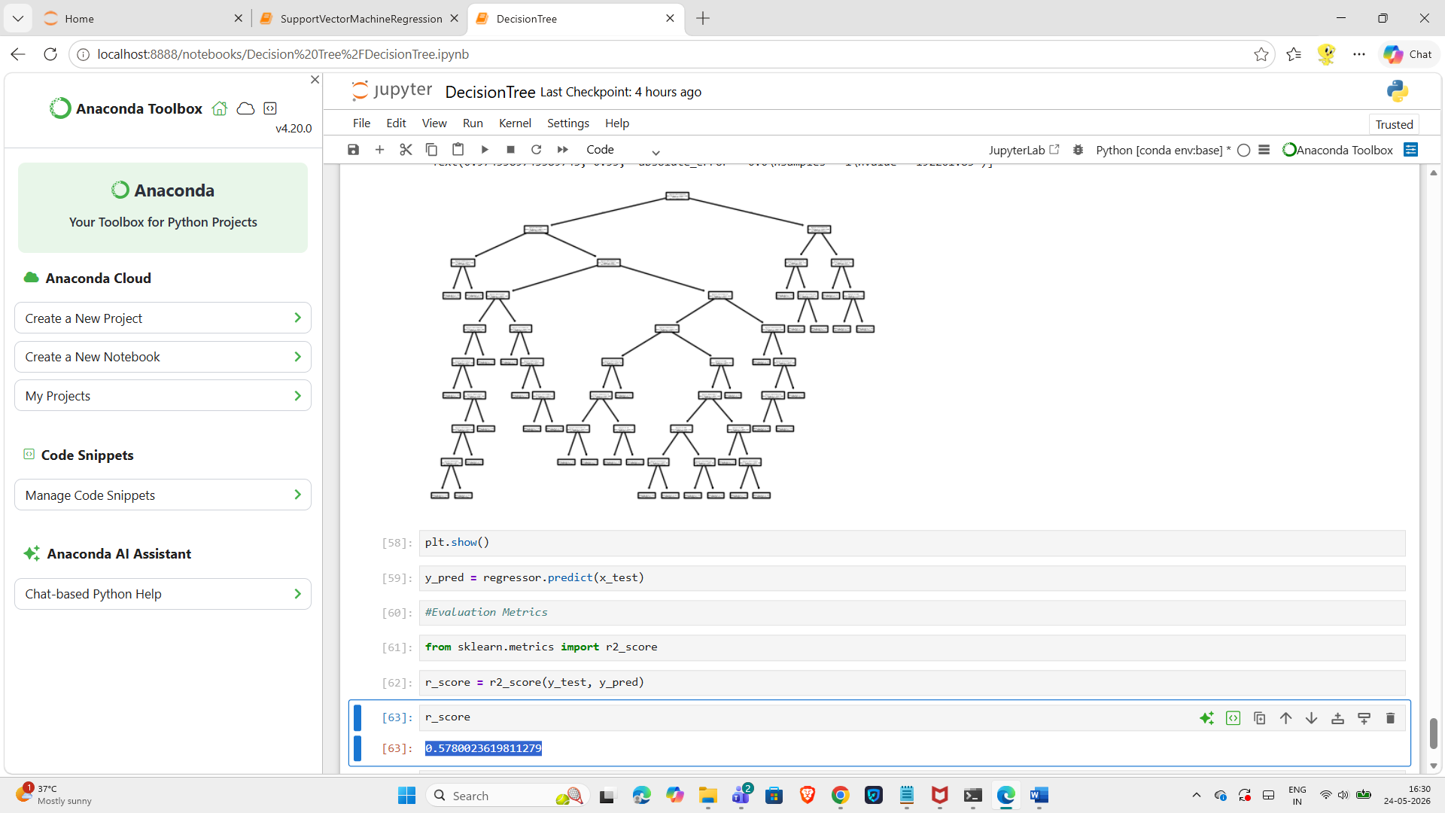

Absolute_error, random, max_features=sqrt
Absolute_error | sqrt | random

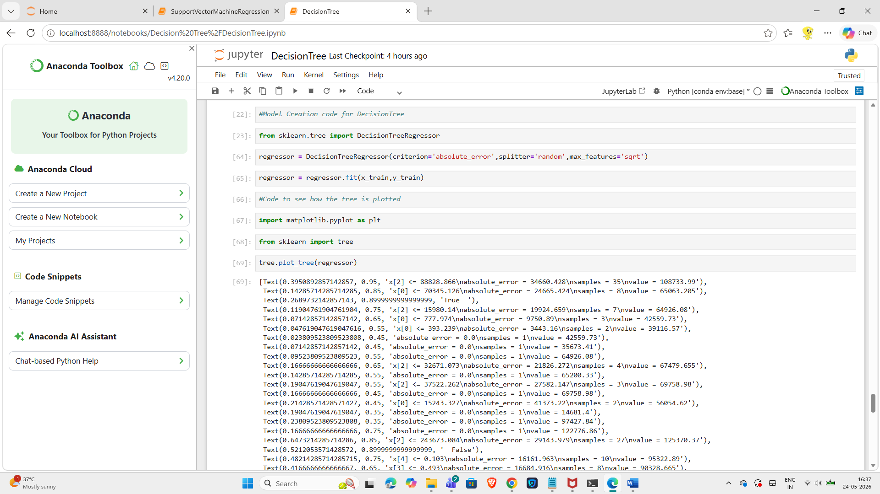
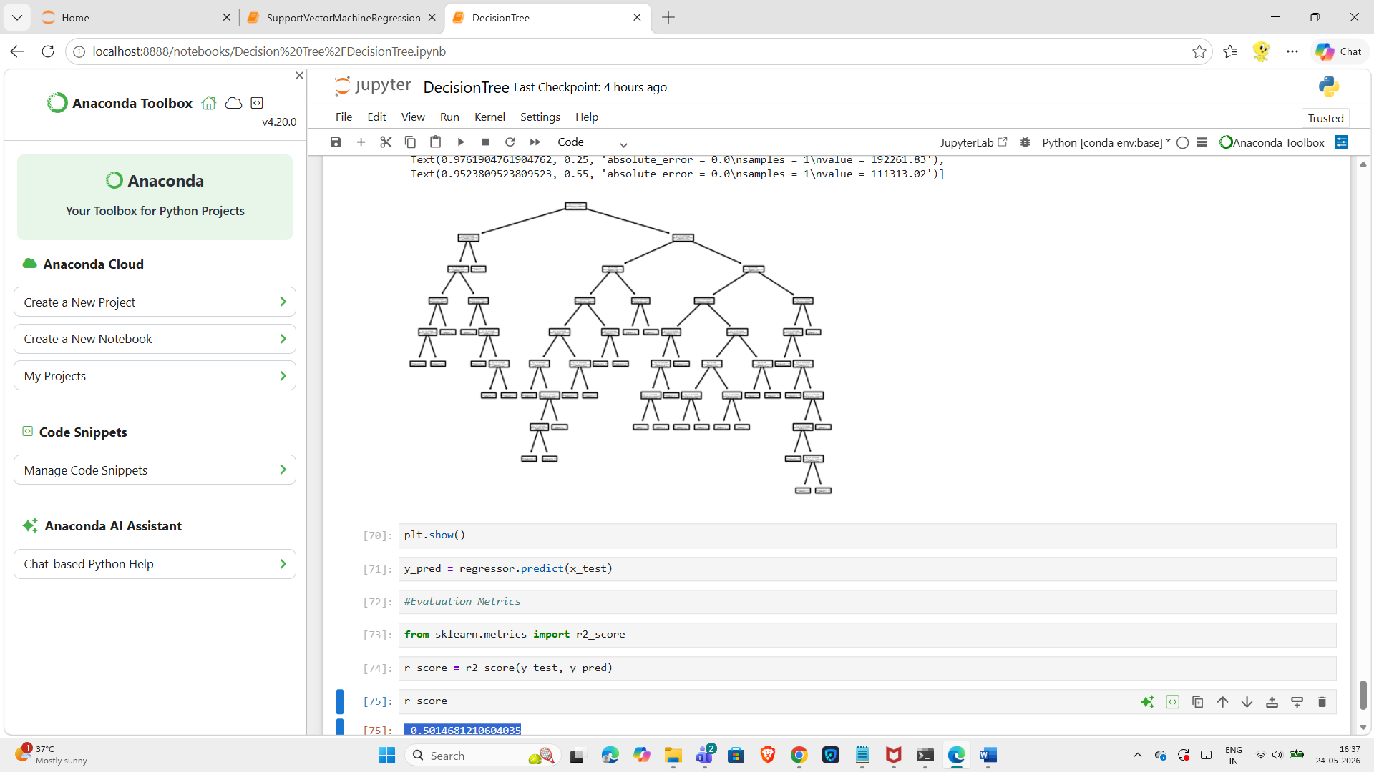

Absolute_error, best, max_features=sqrt
Absolute_error | sqrt | best

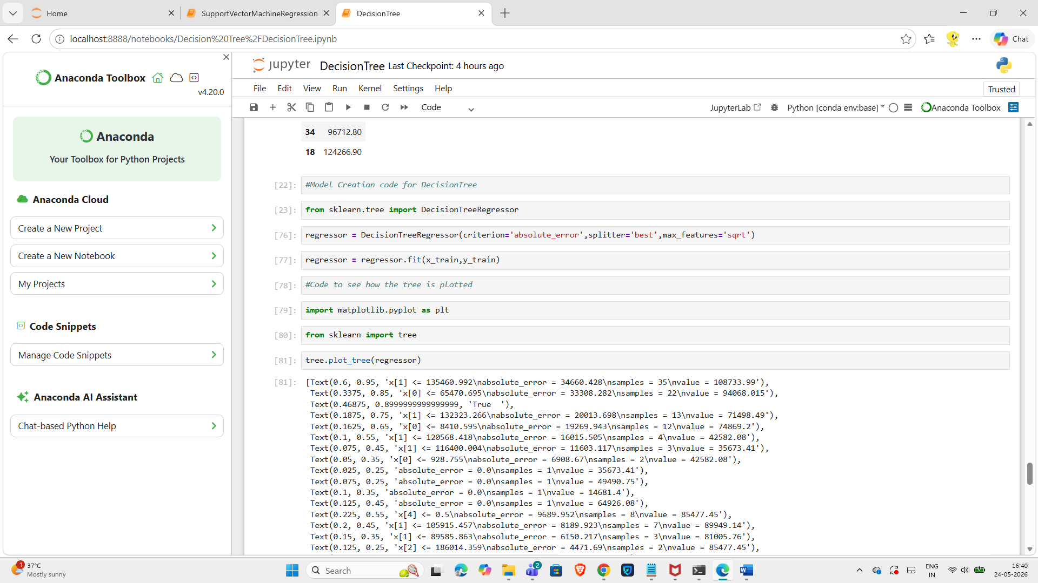
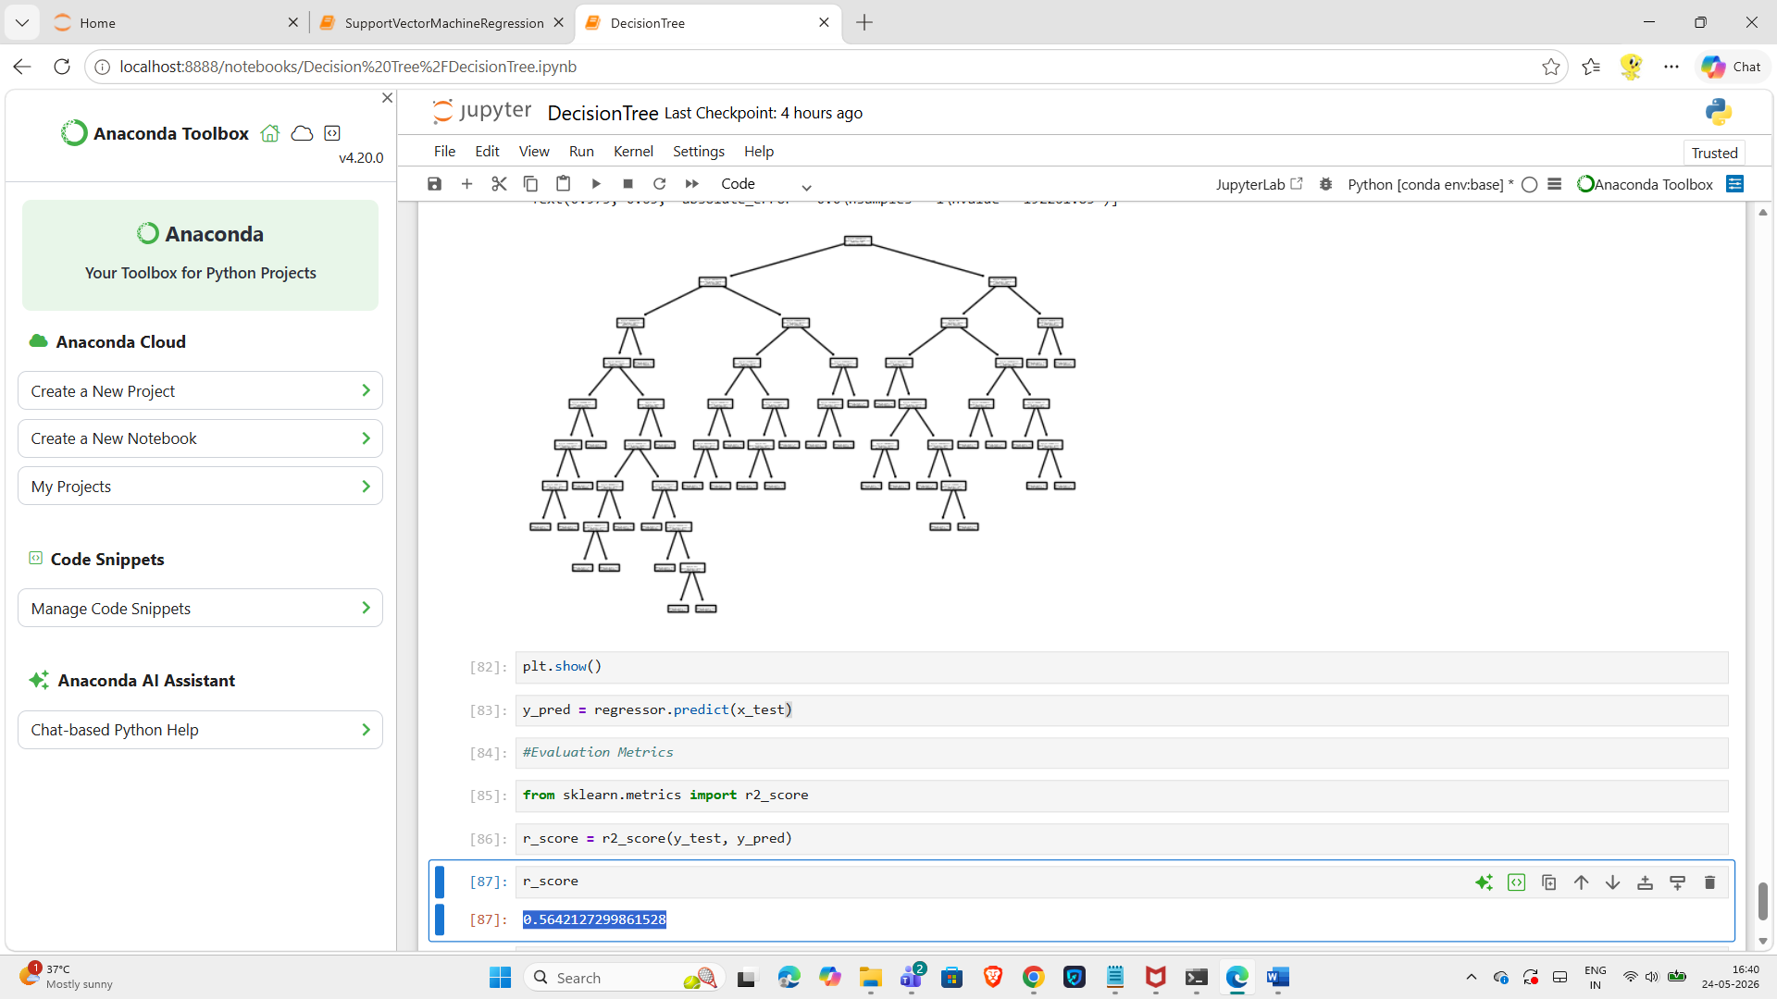

Absolute_error | Log2 | best

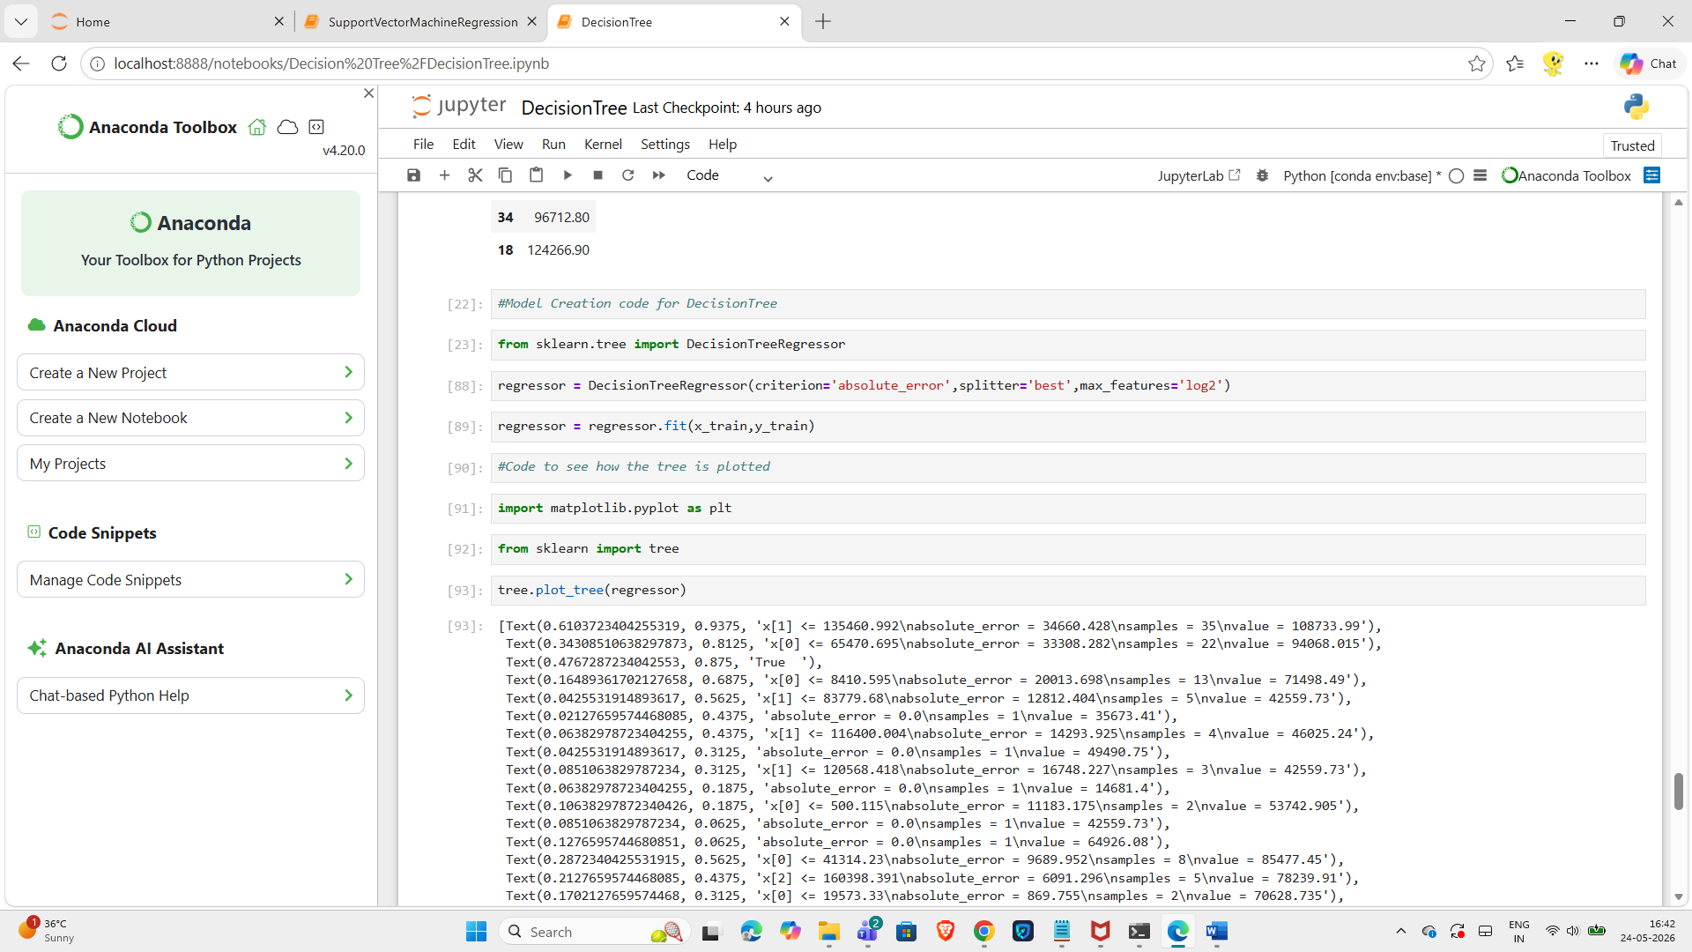
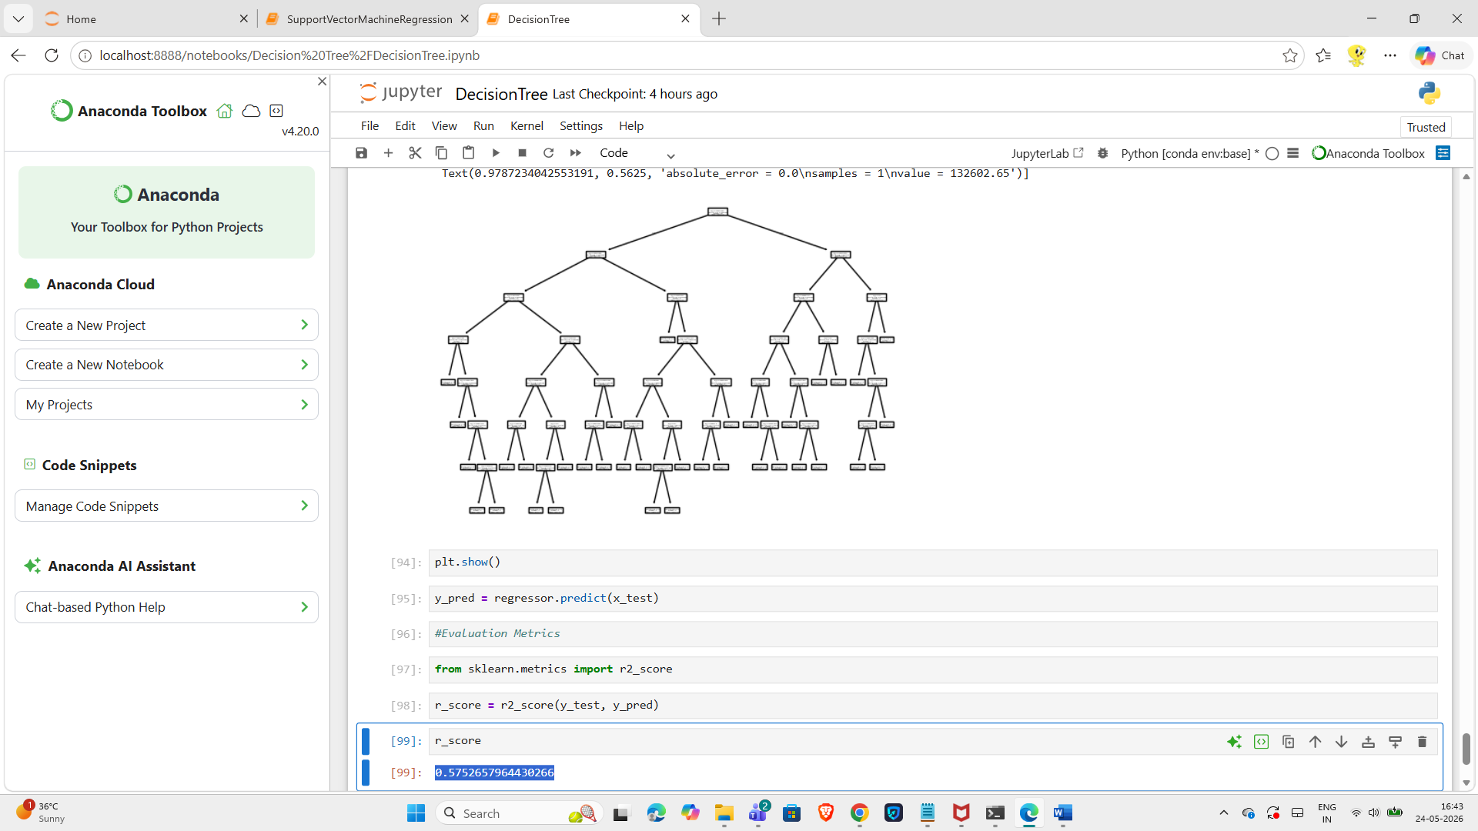

Absolute_error | Log2 | random

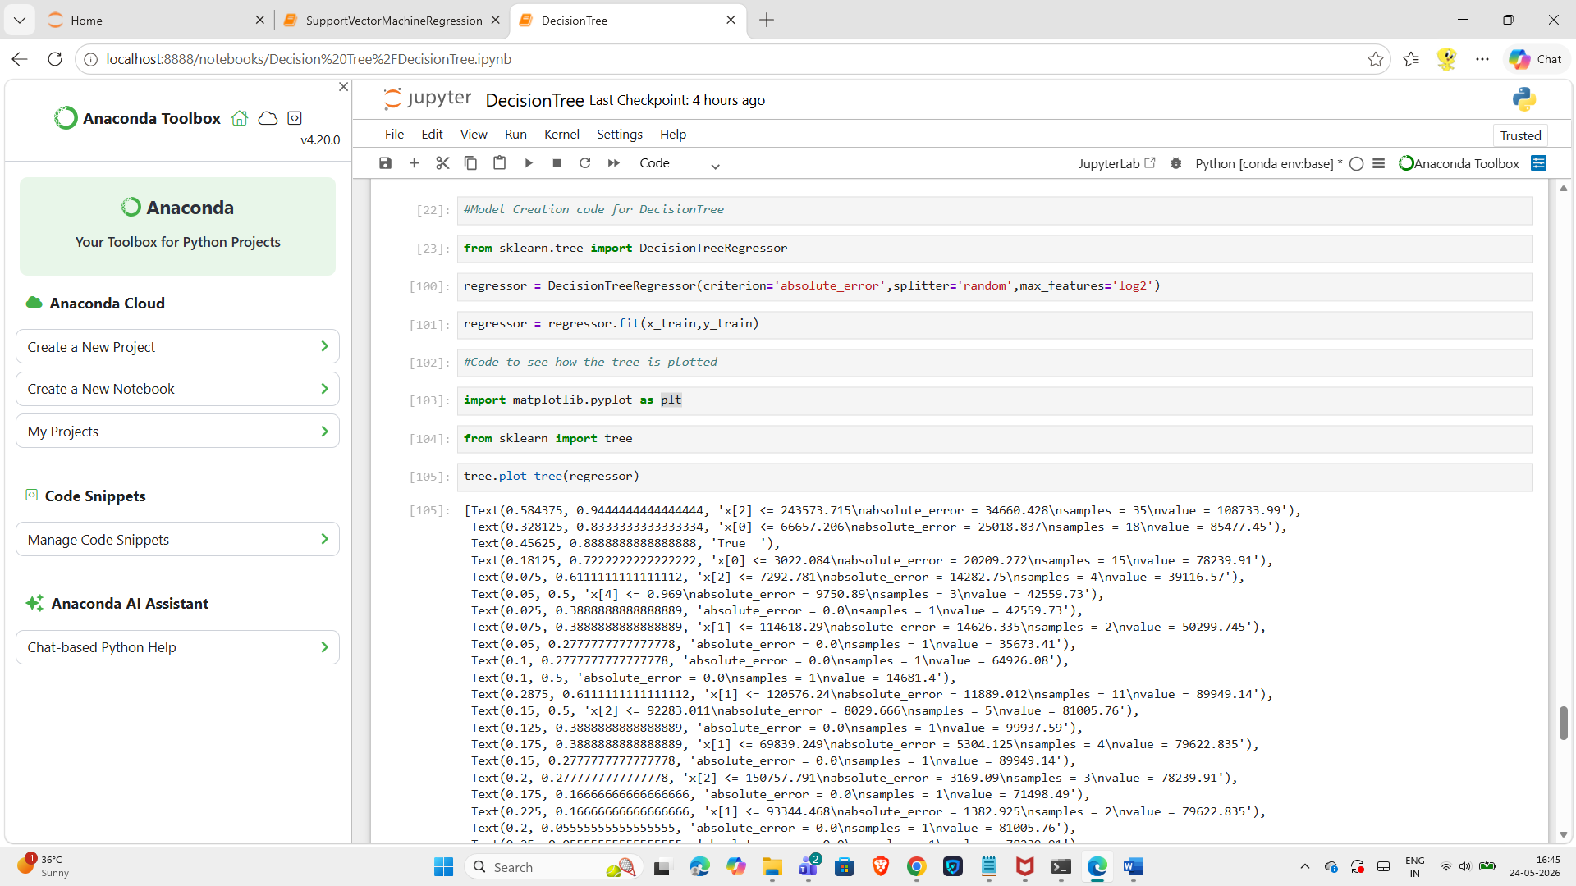
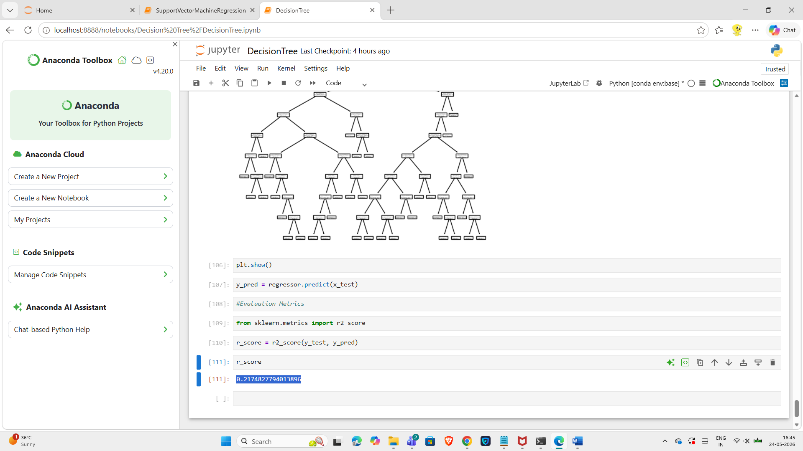

poisson | auto | best

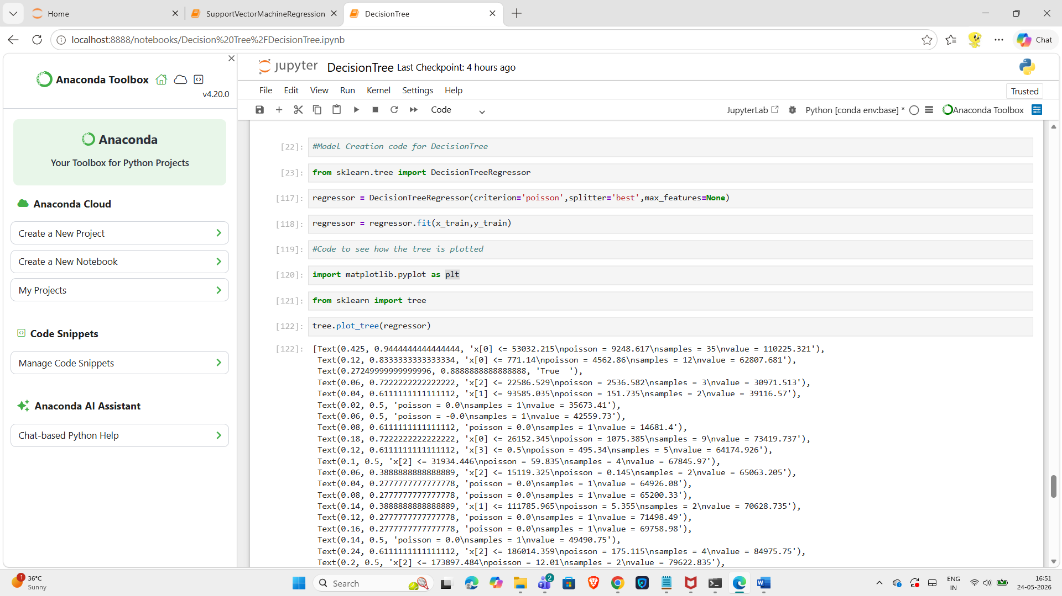
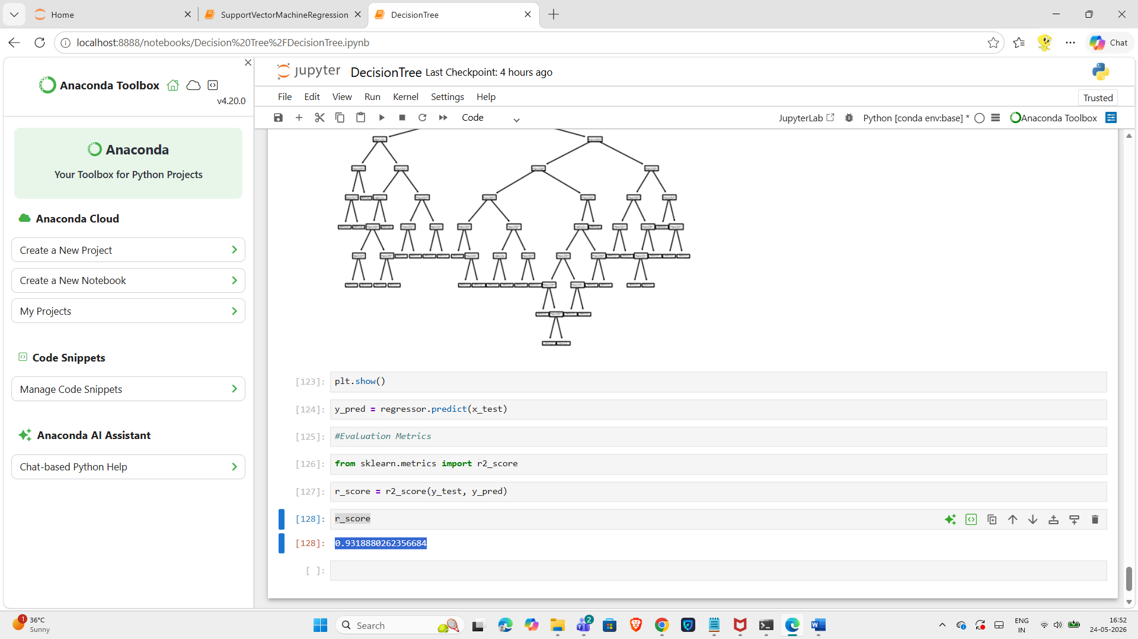

poisson | auto | random

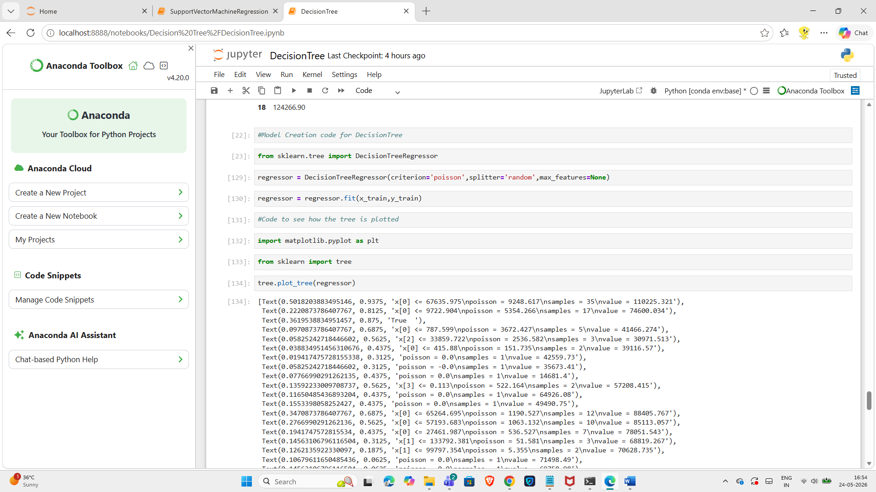
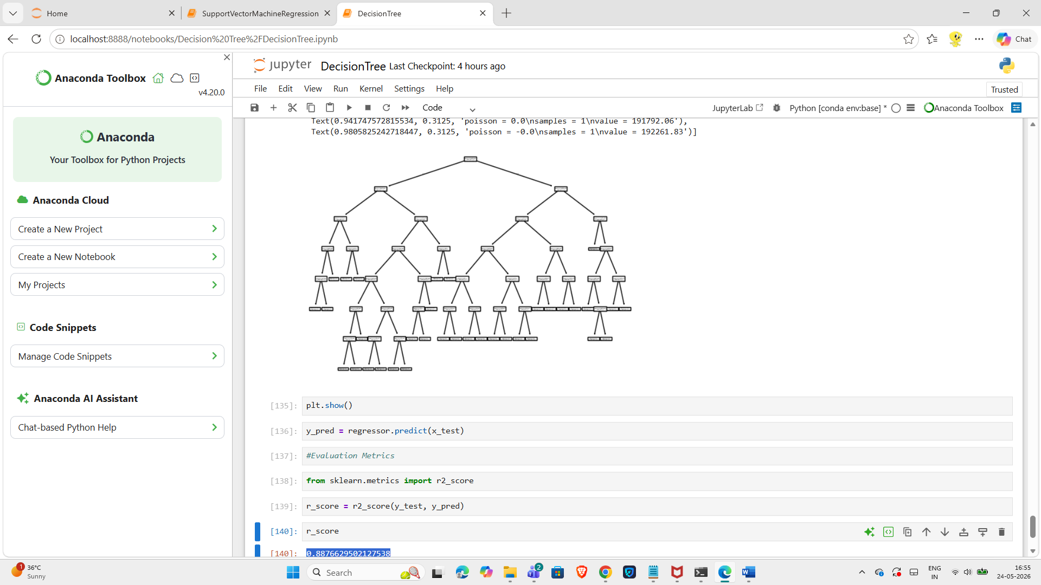

poisson | sqrt | best

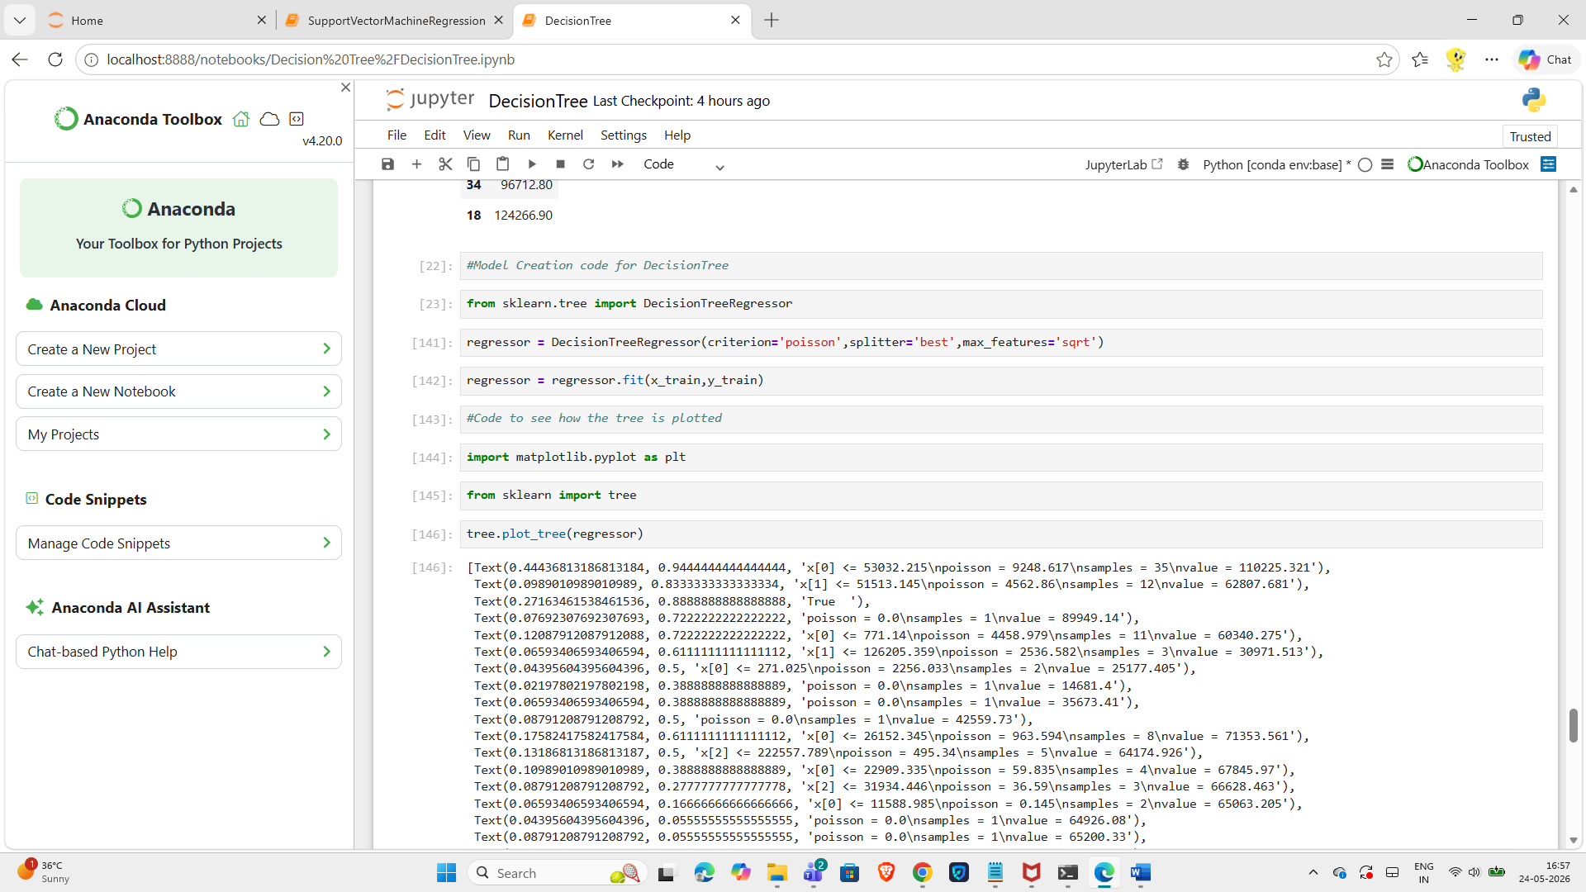
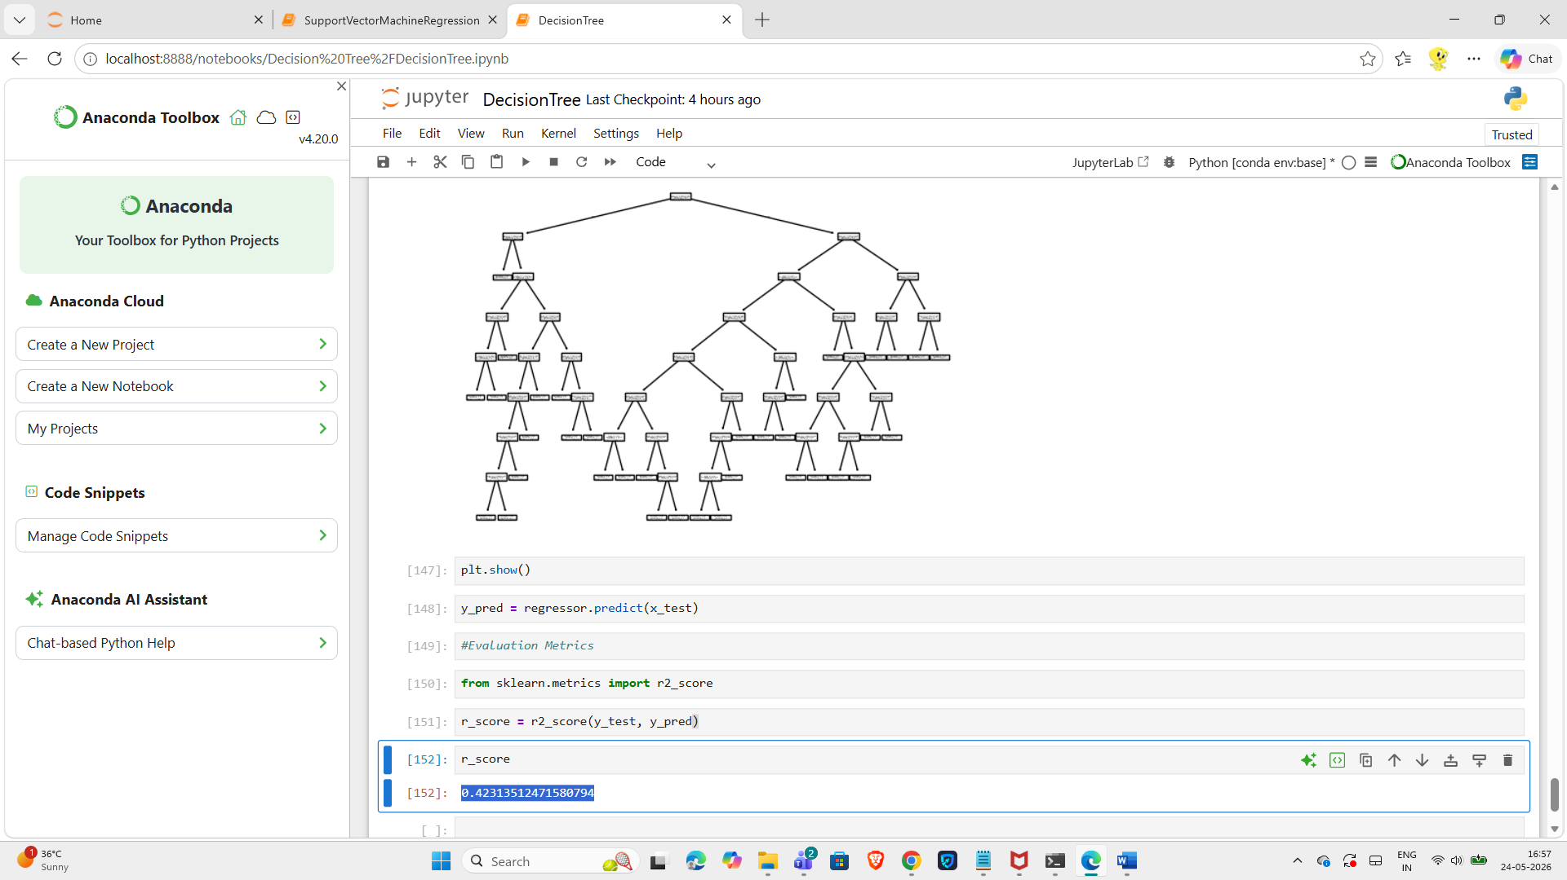

poisson | sqrt | random

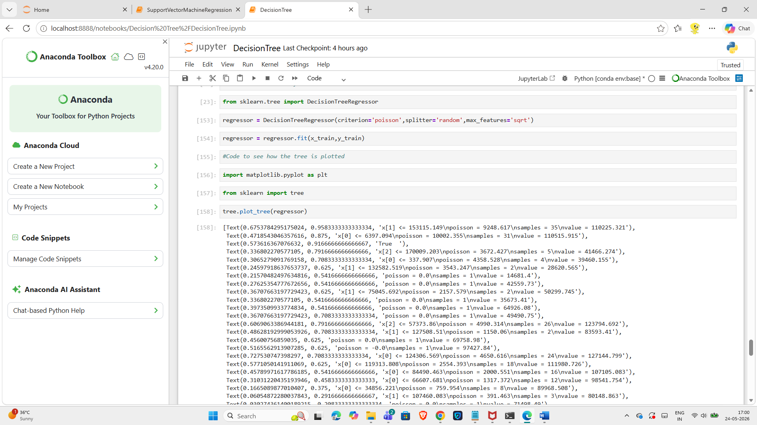
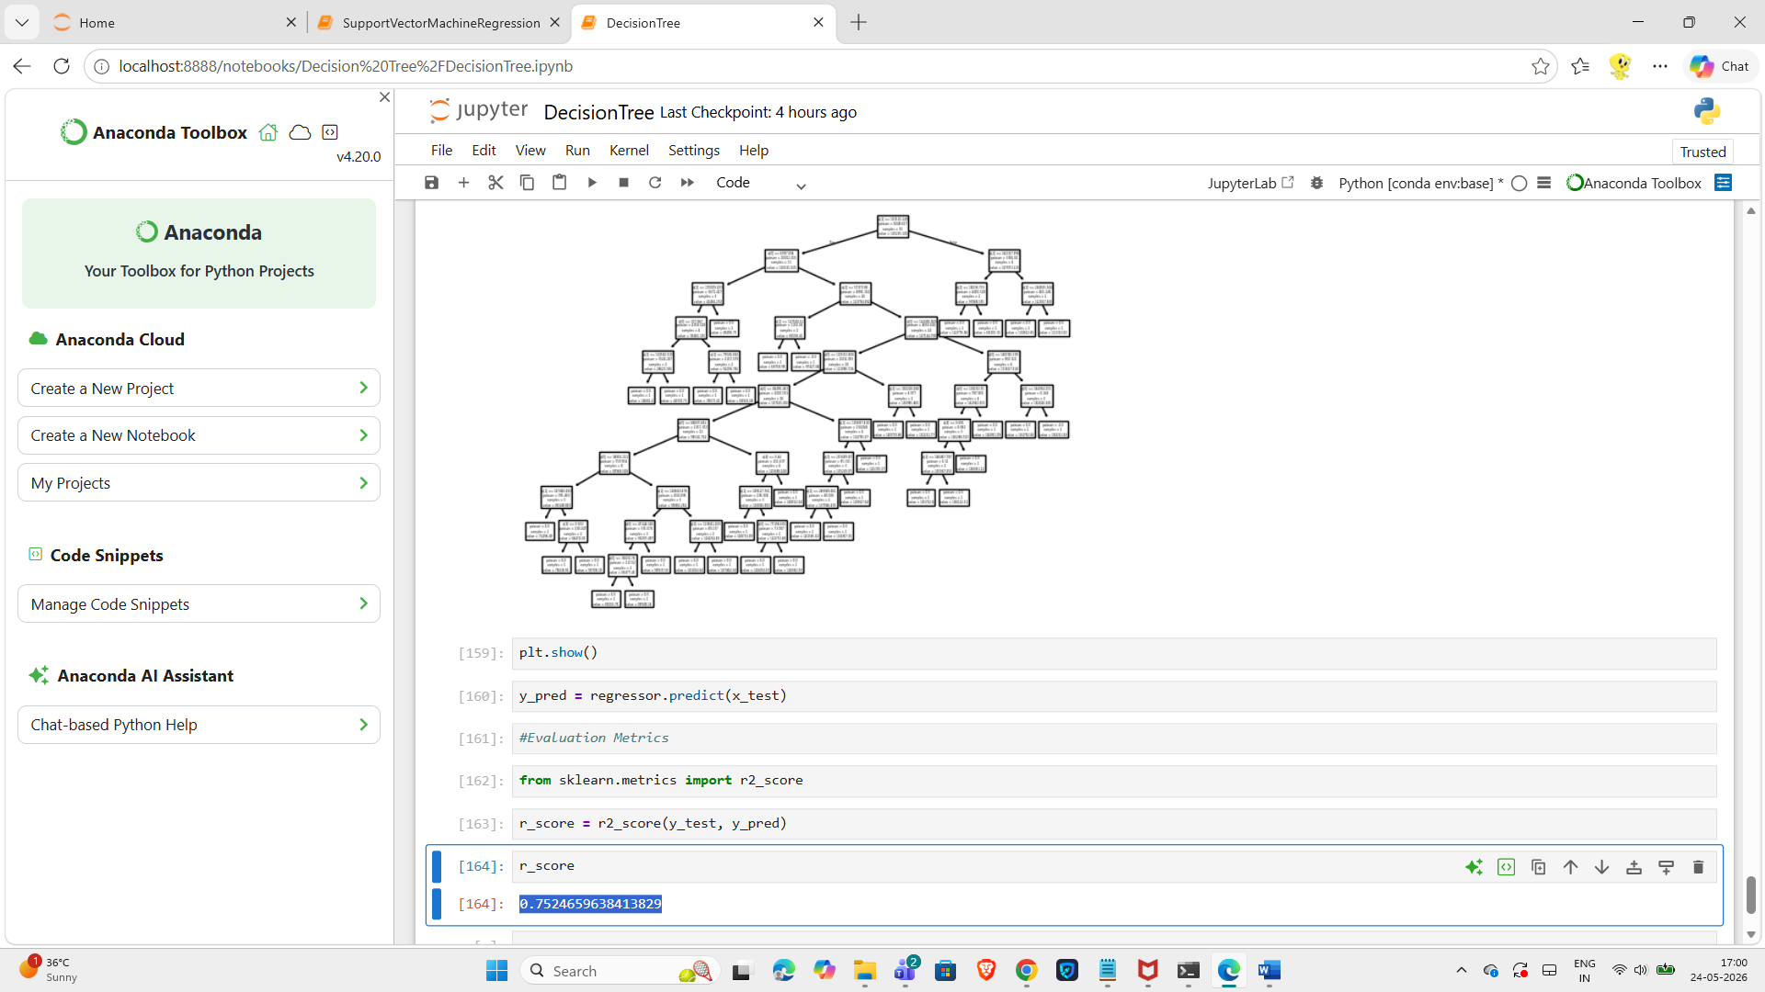

poisson | Log2 | best

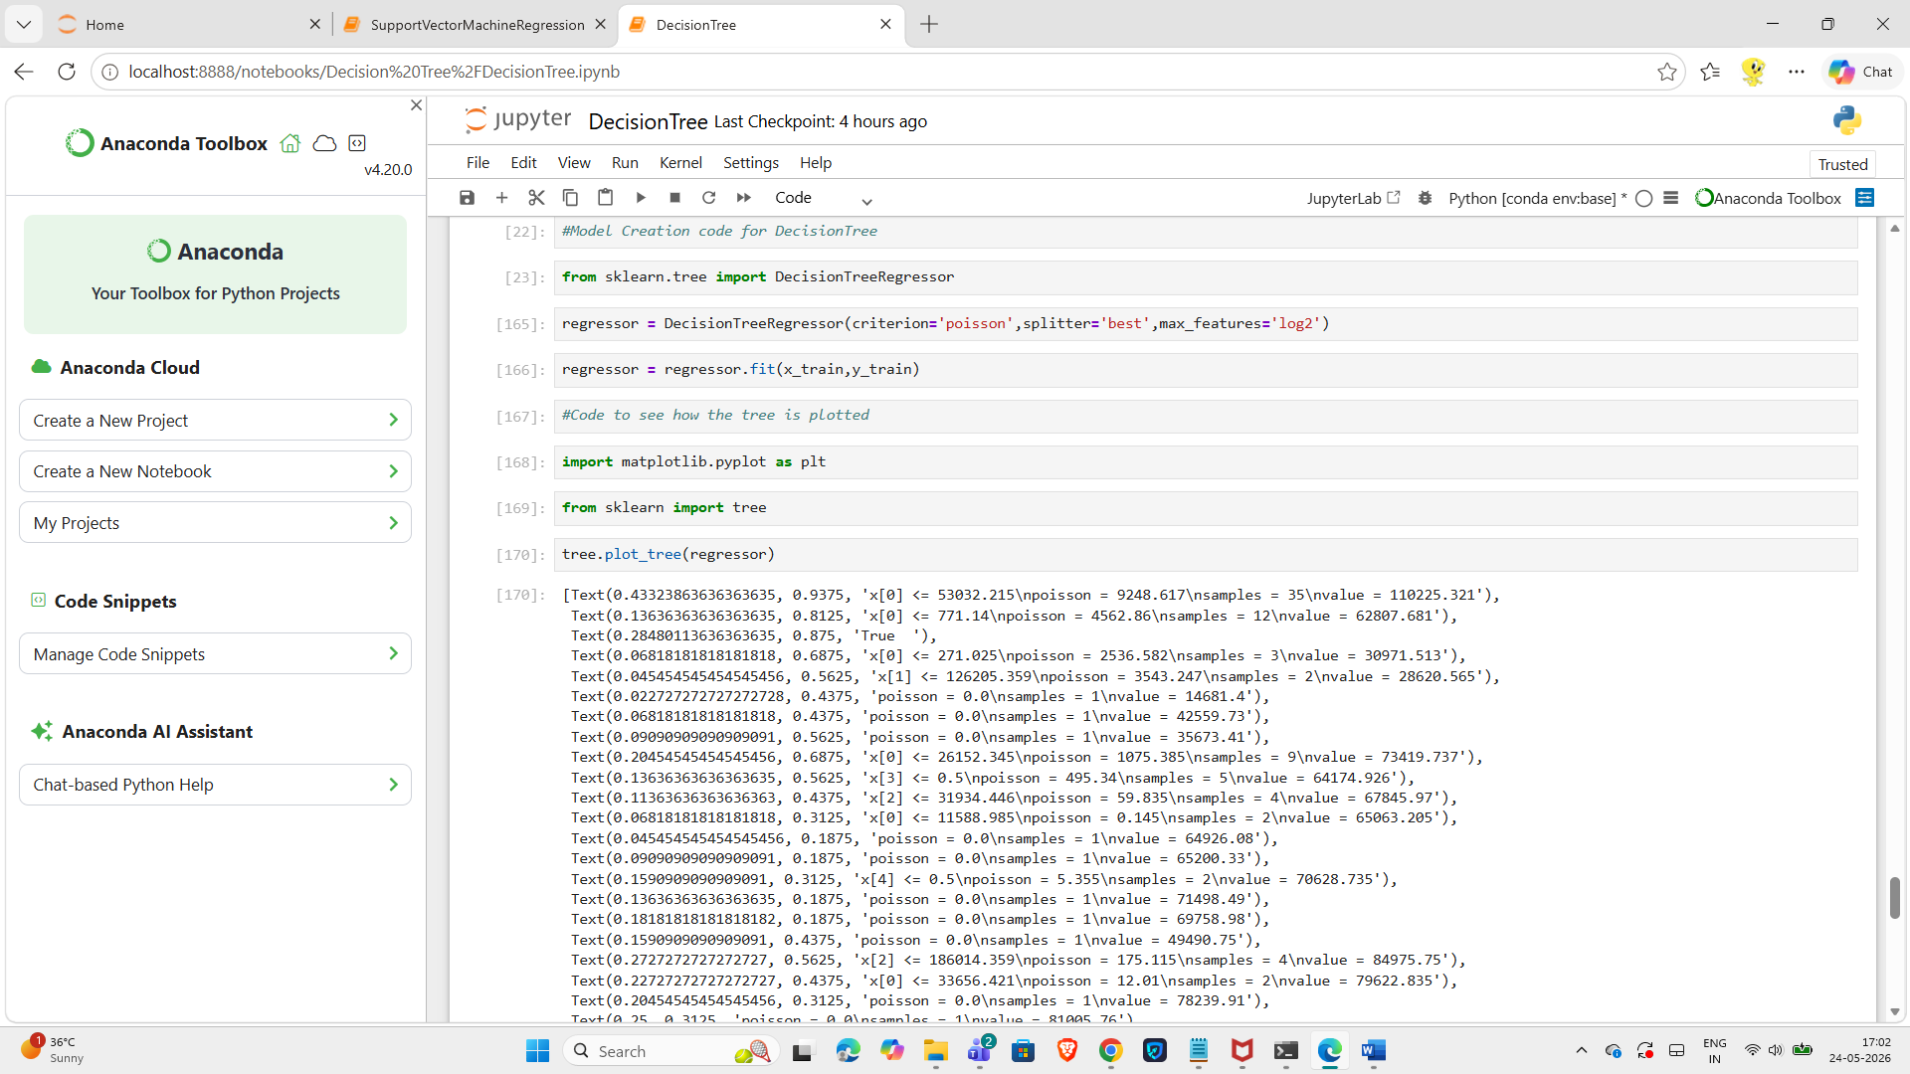
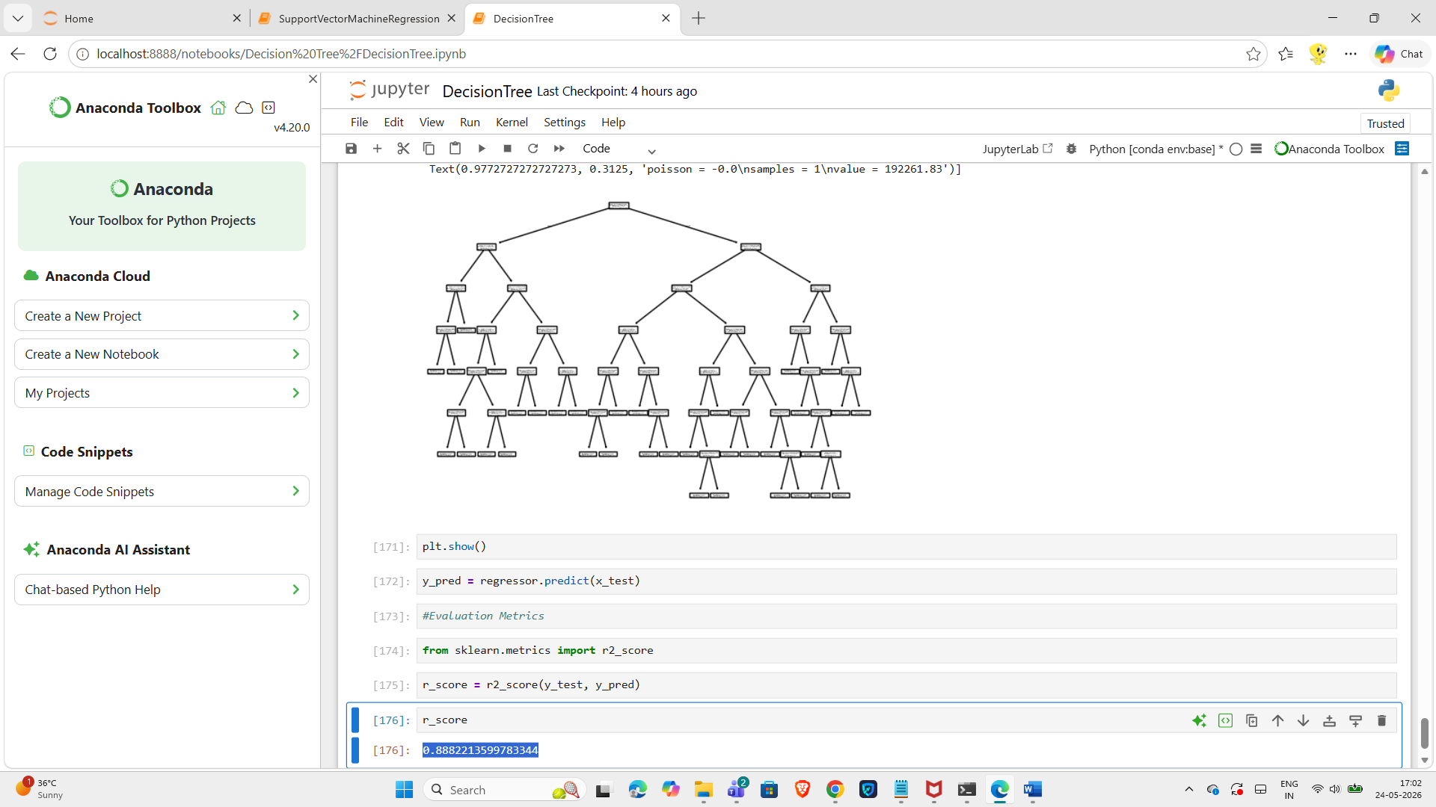

poisson | Log2 | random

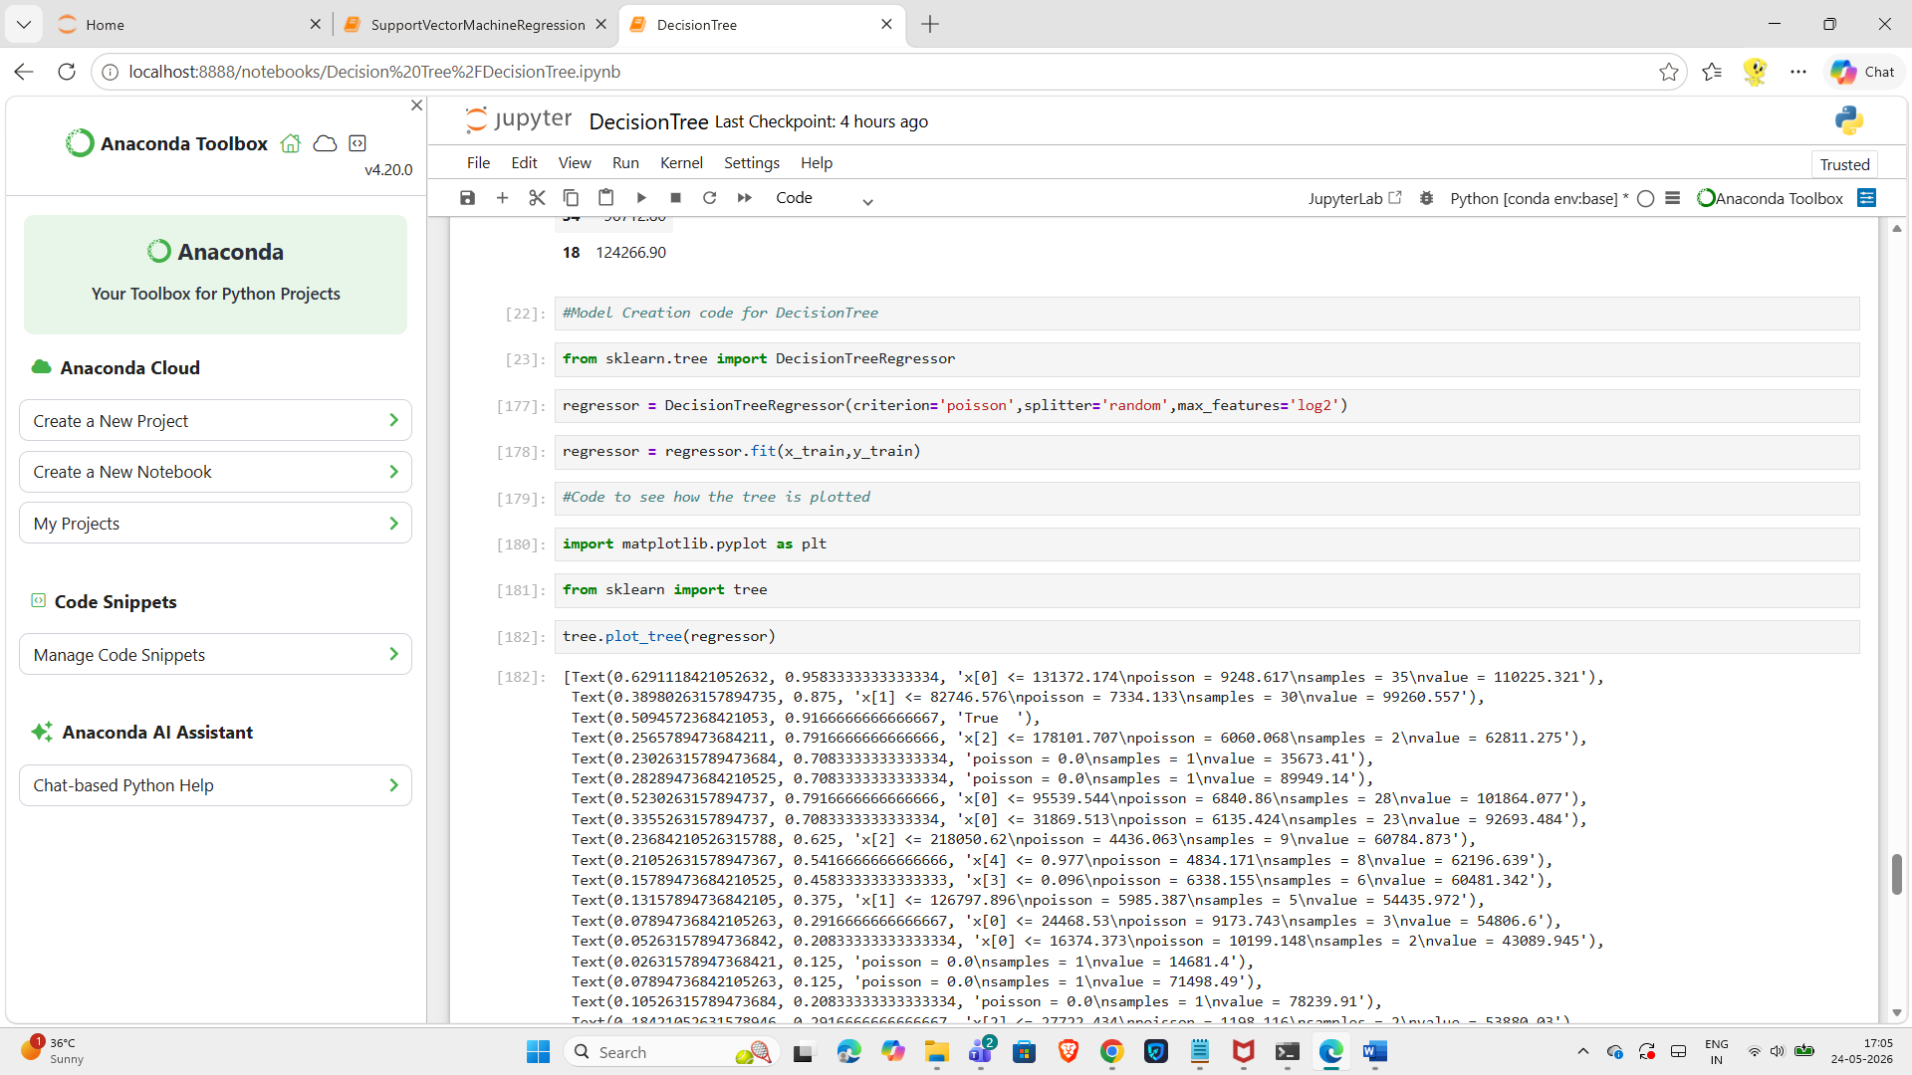
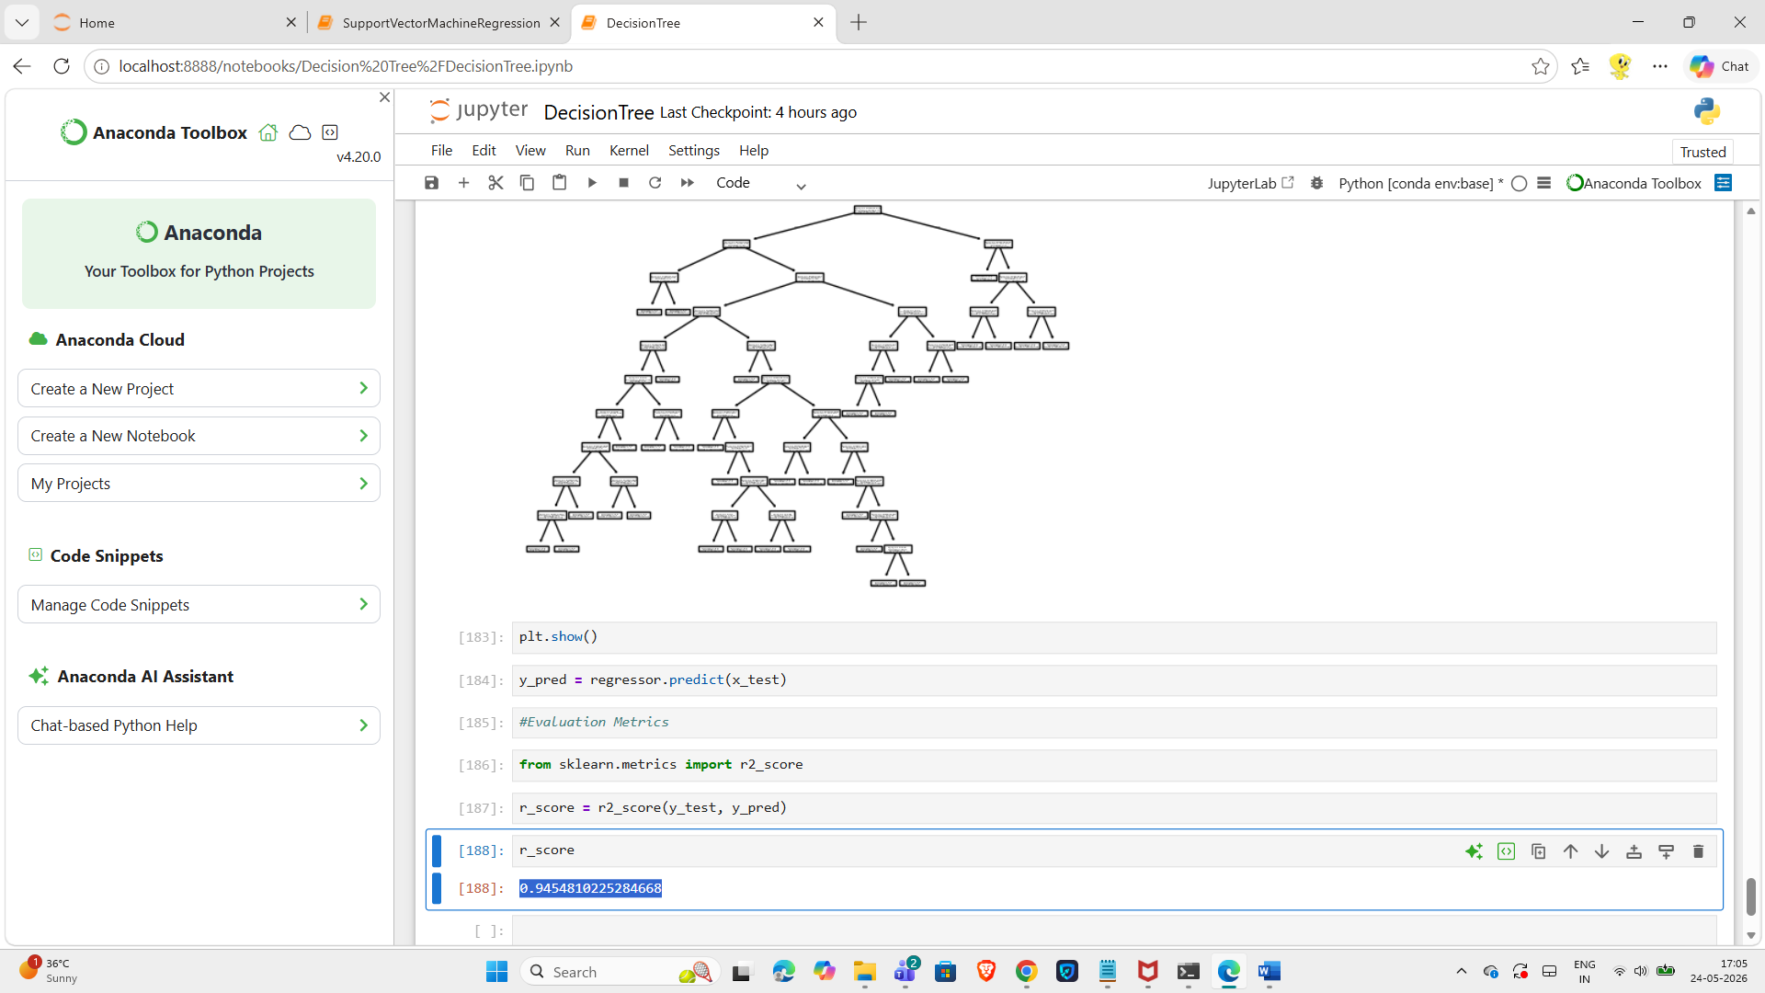

Friedman_mse | auto | best

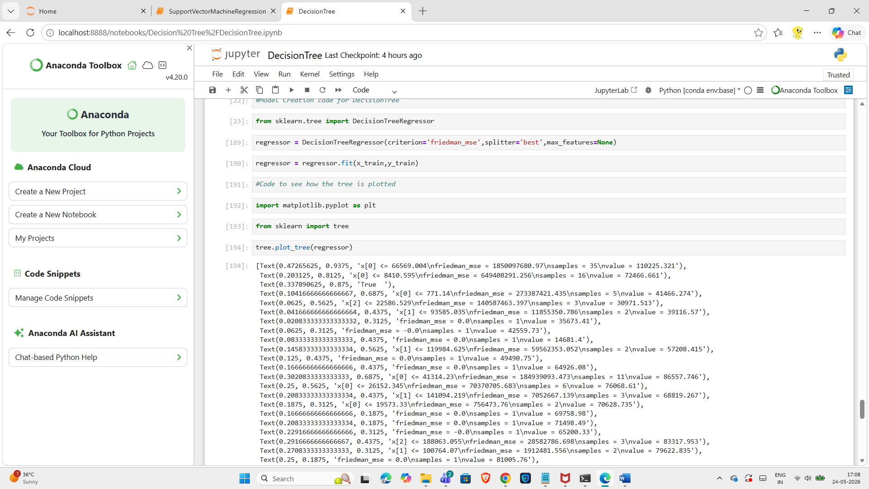
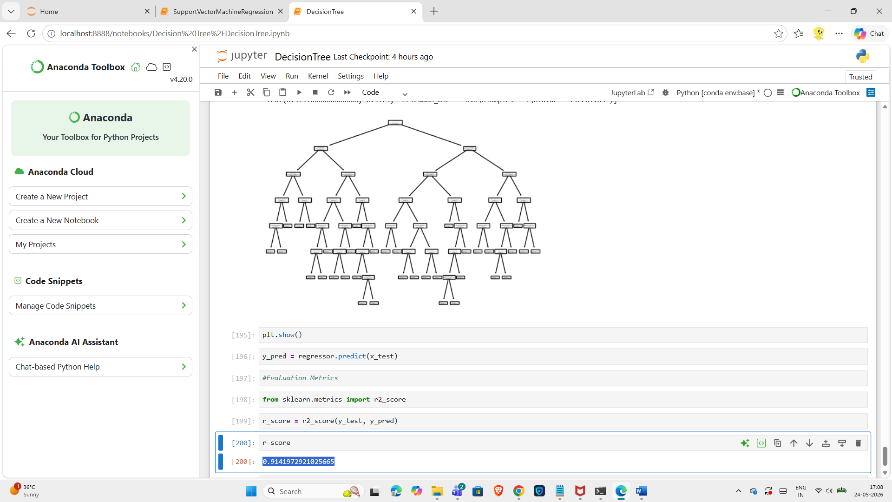

Friedman_mse | auto | random

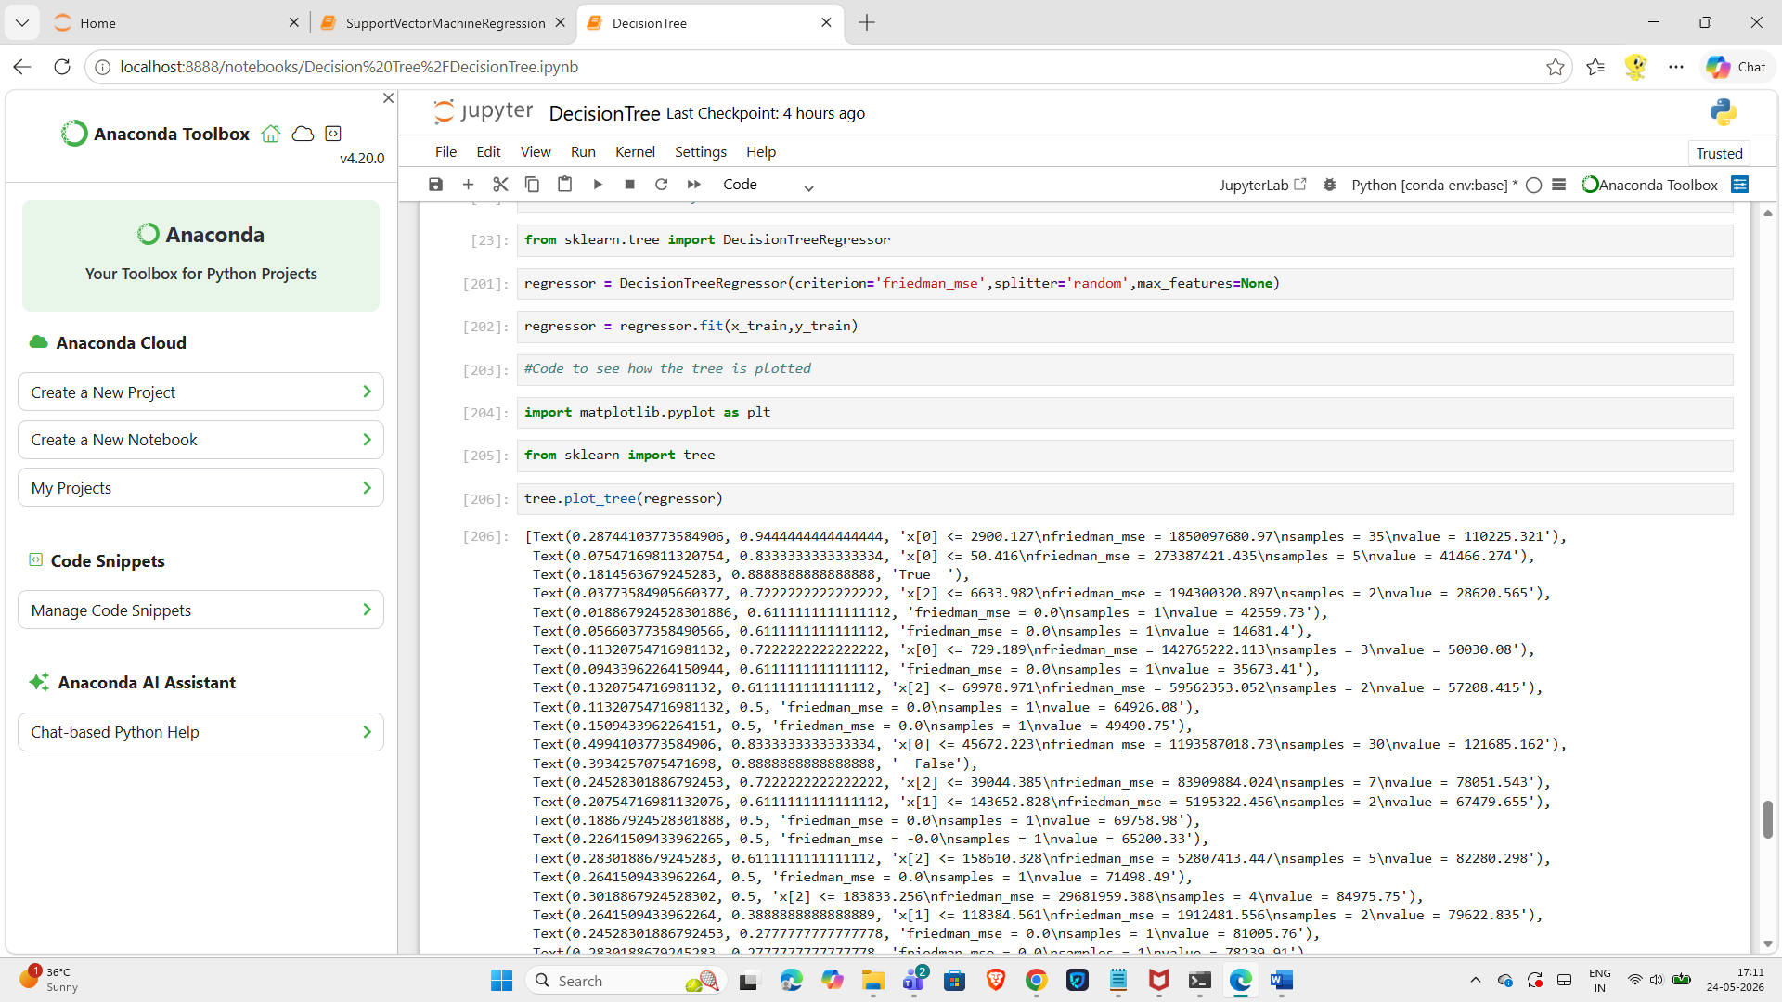
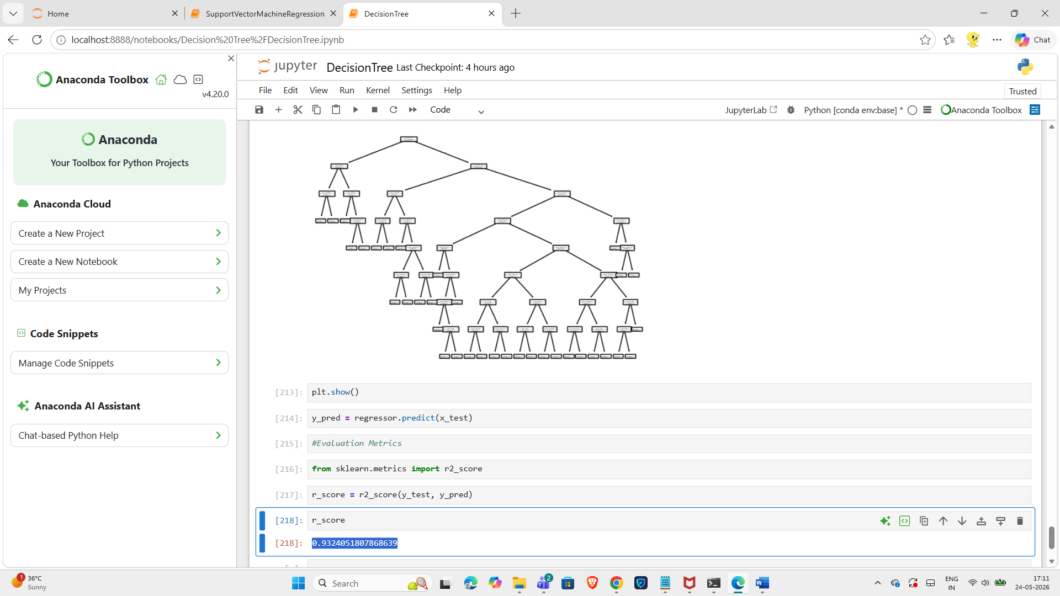

Friedman_mse | sqrt | best

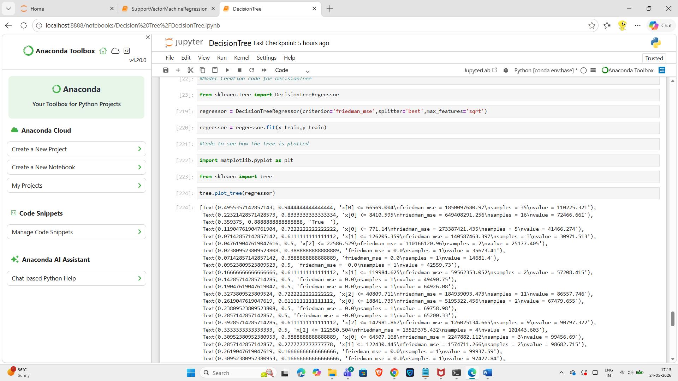
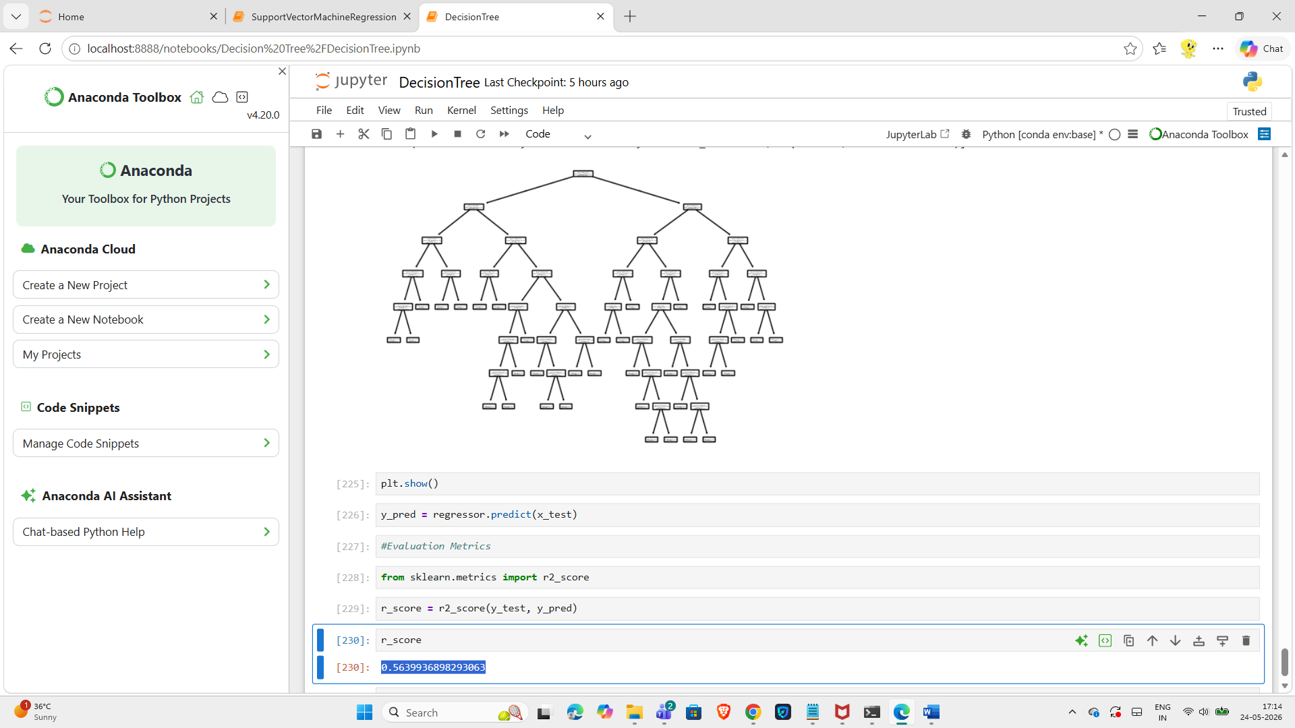

Friedman_mse | sqrt | random

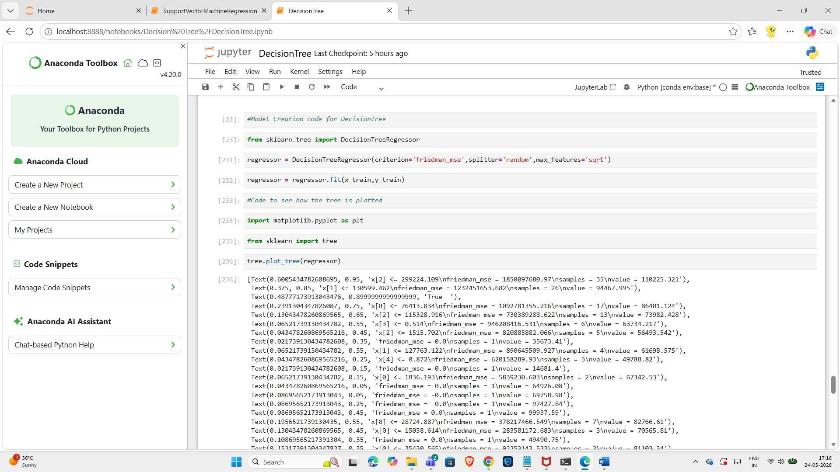
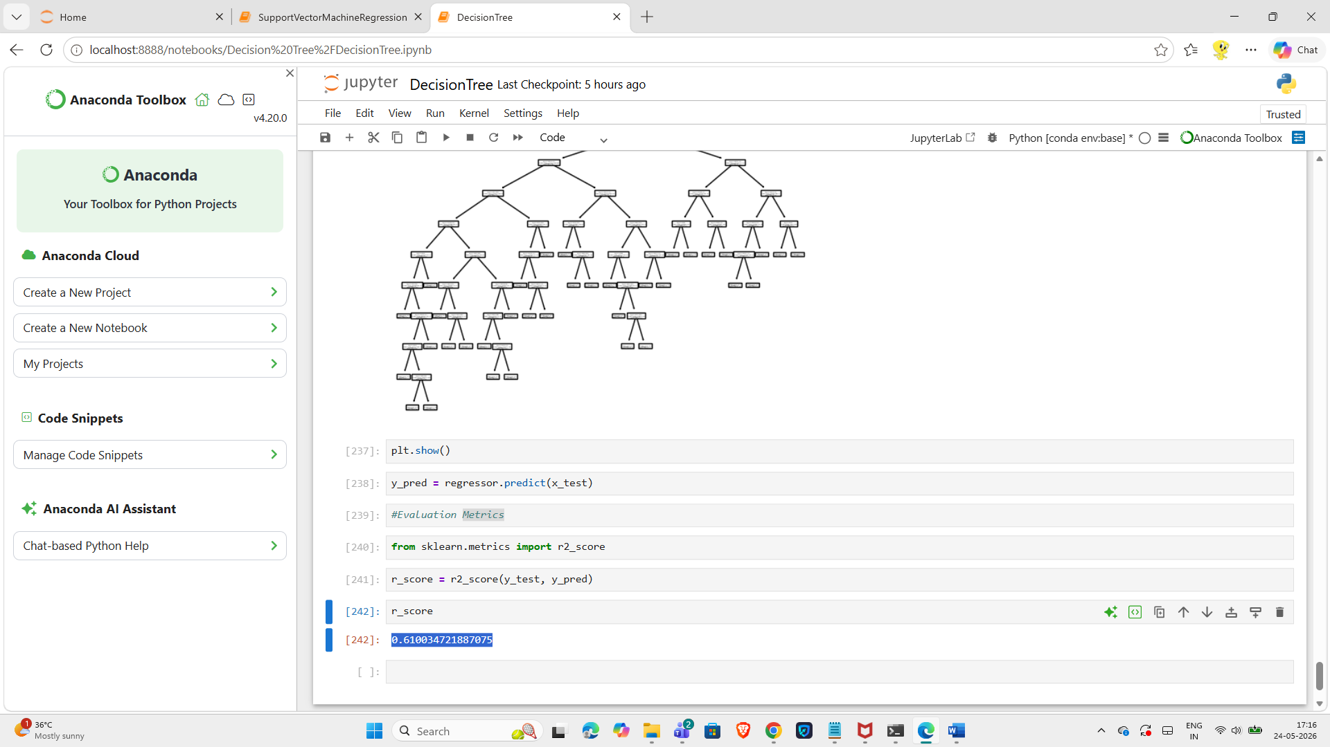

Friedman_mse | Log2 | best

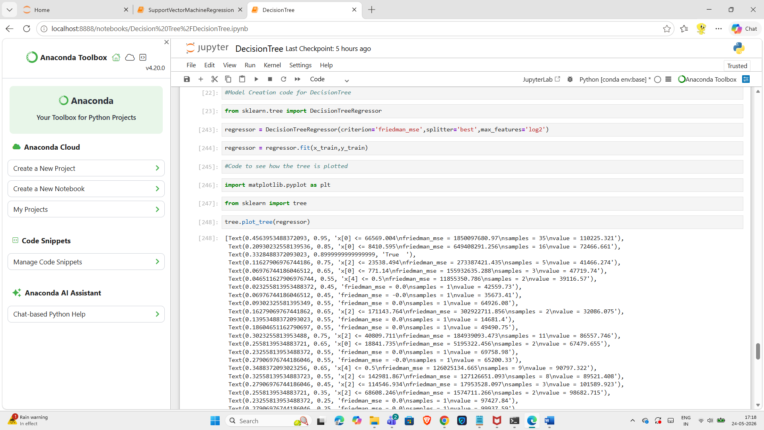
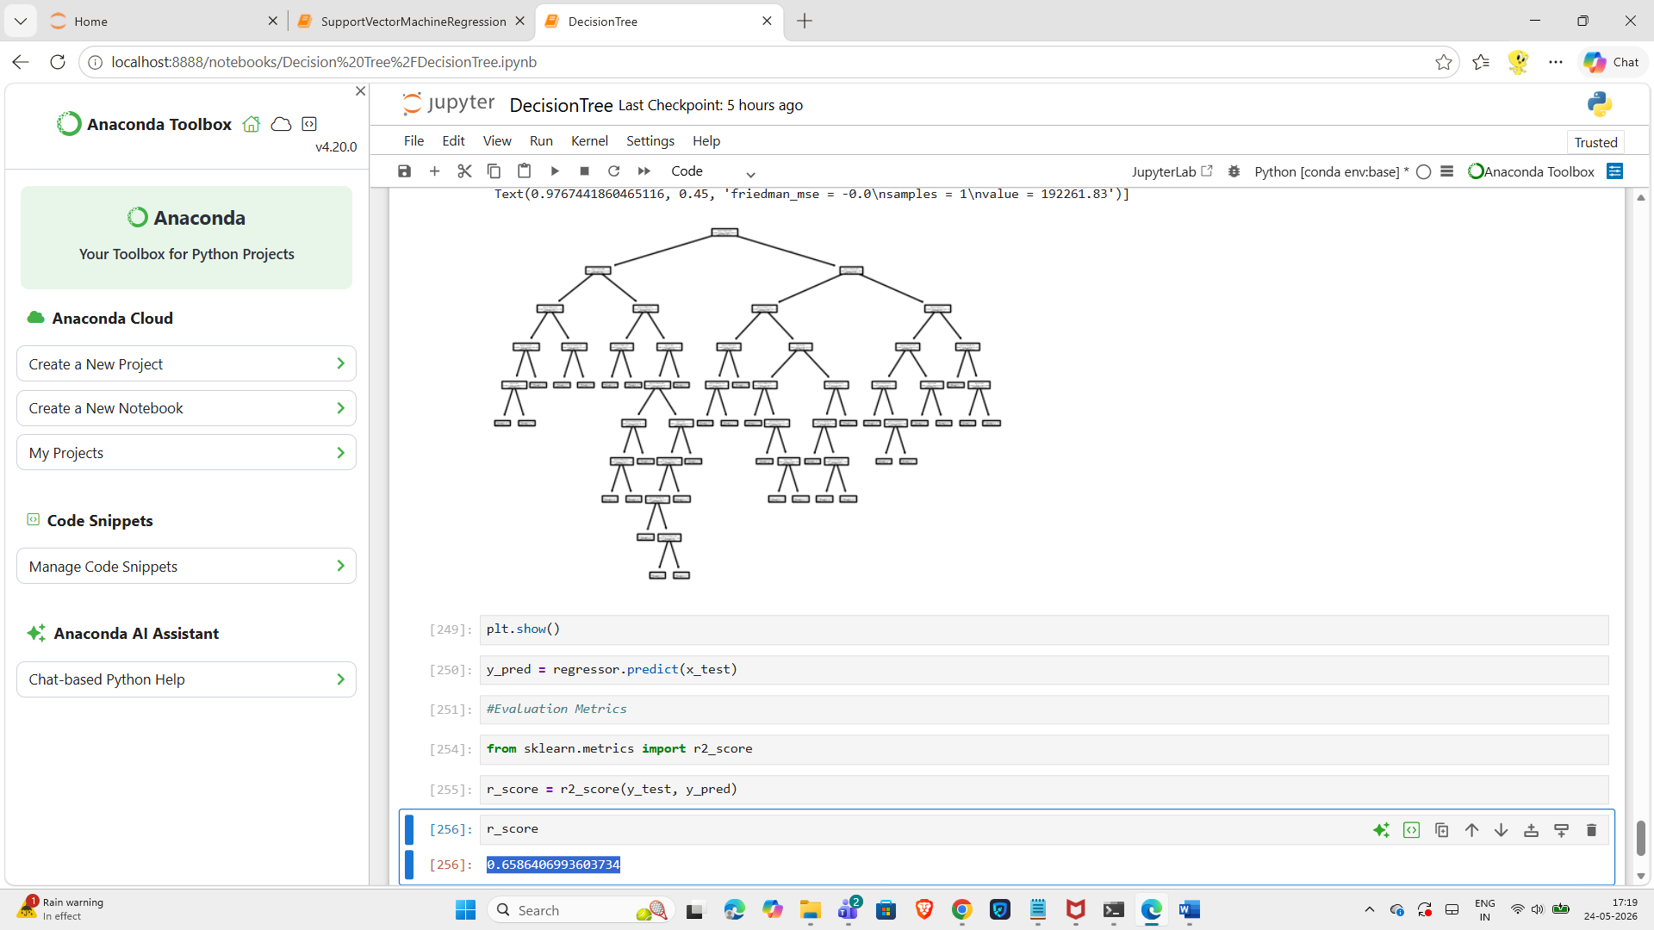

Friedman_mse | Log2 | random

